LAB ASSIGNMENT – 17.1
NAME : J.SANJANA
ROLLNO : 2503A52379
BATCH : 13
Task 1 – Customer Data Cleaning
Aim:
To clean a customer shopping dataset using Python and Pandas by handling missing values, removing duplicate records, standardizing text values and encoding categorical variables.
Prompt:
Generate a Python Pandas script to clean the customer shopping dataset by handling missing values in age, income and city, removing duplicates, converting city names to lowercase, and encoding gender and city using LabelEncoder. Display the cleaned dataset.
Python Code:
import pandas as pd
from sklearn.preprocessing import LabelEncoder

# Load dataset
data = pd.read_csv("shopping_trends.csv")

print("Original Dataset:")
print(data.head())

# Remove duplicate records
data = data.drop_duplicates()

# Handle missing numerical values
for col in ["Age", "income"]:
if col in data.columns:
data[col] = data[col].fillna(data[col].median())

# Handle missing city/location values
for col in ["city", "Location"]:
if col in data.columns:
data[col] = data[col].fillna("unknown")

# Standardize text values
for col in data.select_dtypes(include="object").columns:
data[col] = data[col].str.strip()

# Convert city or location names to lowercase
for col in ["city", "Location"]:
if col in data.columns:
data[col] = data[col].str.lower()

# Encode gender and city/location
encoder = LabelEncoder()

for col in ["Gender", "city", "Location"]:
if col in data.columns:
data[col] = encoder.fit_transform(data[col].astype(str))

# Display cleaned dataset
print("\nCleaned Dataset:")
print(data.head())

print("\nMissing Values:")
print(data.isnull().sum())

# Save cleaned dataset
data.to_csv("cleaned_customer_data.csv", index=False)

print("\nCleaned data saved successfully!")
Output:
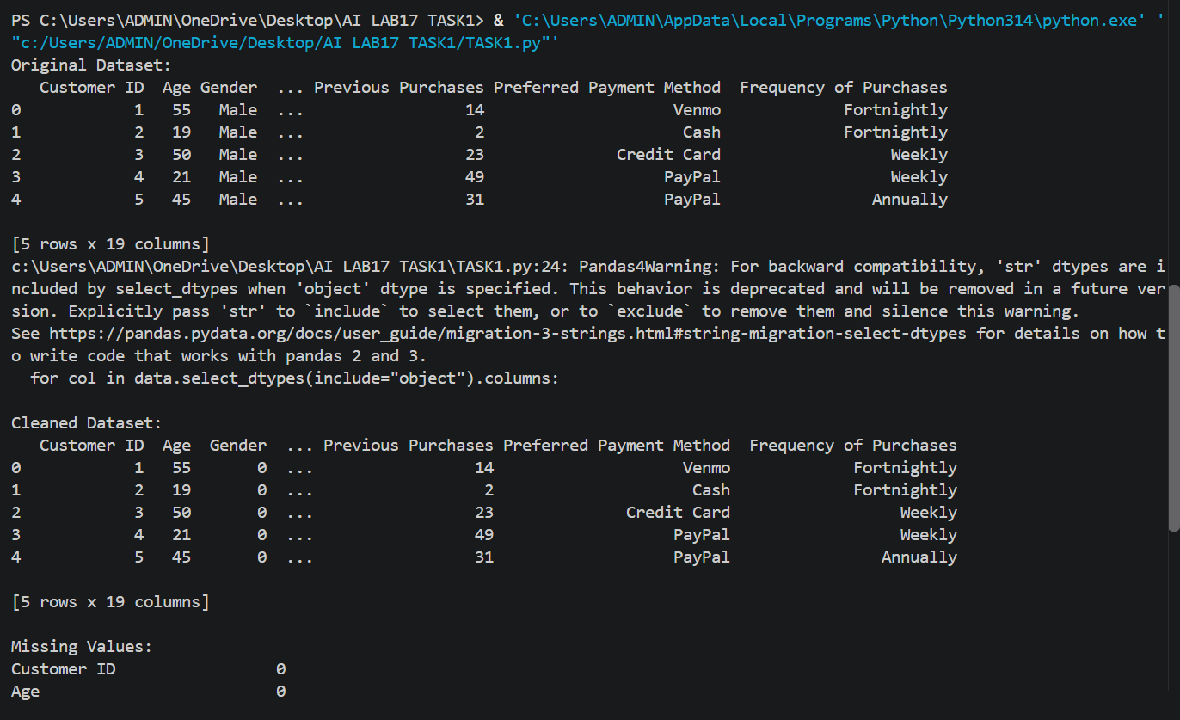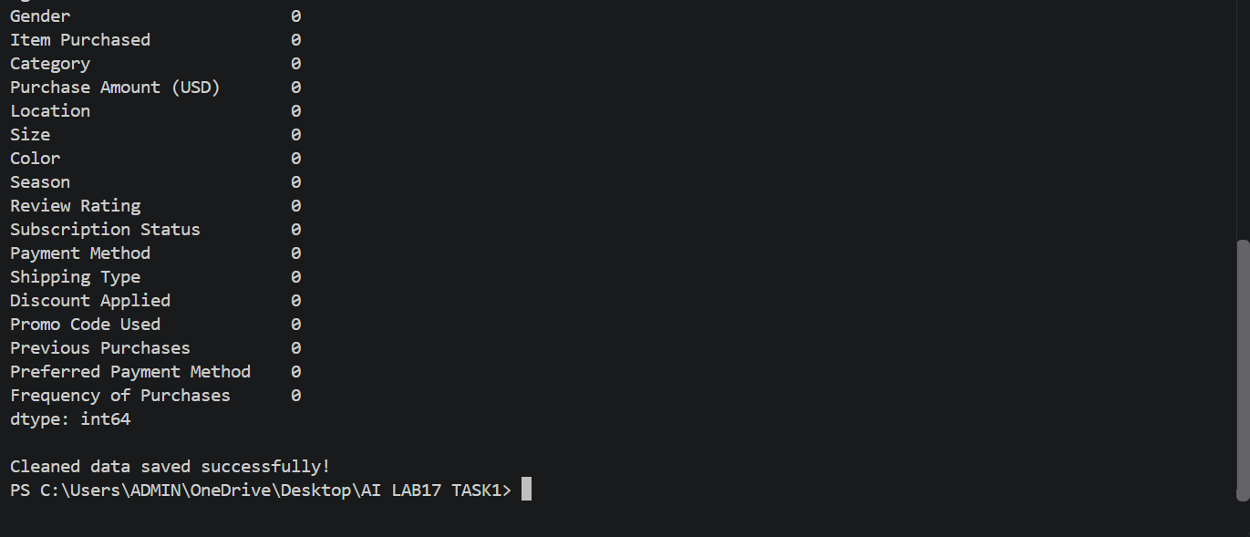
Task 2 – Sales Data Preprocessing
Aim:
To preprocess sales transaction data using Python and Pandas by converting date columns into datetime format, creating time-based
features, normalizing sales amounts, and detecting and handling outliers.
Prompt:
Generate a Python Pandas script to preprocess the sales dataset by converting date columns into datetime format, extracting month, year and day of the week, normalizing the sales amount using Min-Max scaling, and detecting and handling outliers using the IQR method. Display and save the transformed dataset.
Python Code:

import pandas as pd

# Load the sales dataset
data = pd.read_csv("sales_data.csv")

print("Original Dataset:")
print(data.head())

# Convert Sale_Date into datetime format
data["Sale_Date"] = pd.to_datetime(data["Sale_Date"])

# Create time-based features
data["Month"] = data["Sale_Date"].dt.month
data["Year"] = data["Sale_Date"].dt.year
data["Day_of_Week"] = data["Sale_Date"].dt.day_name()

# Handle missing sales amounts
data["Sales_Amount"] = data["Sales_Amount"].fillna(
data["Sales_Amount"].median()
)

# Detect outliers using IQR method
Q1 = data["Sales_Amount"].quantile(0.25)
Q3 = data["Sales_Amount"].quantile(0.75)
IQR = Q3 - Q1

lower_limit = Q1 - 1.5 * IQR
upper_limit = Q3 + 1.5 * IQR

# Handle outliers by replacing them with boundary values
data["Sales_Amount"] = data["Sales_Amount"].clip(
lower=lower_limit,
upper=upper_limit
)

# Normalize sales amount using Min-Max normalization
minimum = data["Sales_Amount"].min()
maximum = data["Sales_Amount"].max()

if maximum != minimum:
data["Normalized_Sales"] = (
(data["Sales_Amount"] - minimum) /
(maximum - minimum)
)
else:
data["Normalized_Sales"] = 0.0

# Display transformed dataset
print("\nTransformed Dataset:")
print(data.head())

# Display dataset information
print("\nDataset Information:")
print(data.info())

# Save transformed dataset
data.to_csv("preprocessed_sales_data.csv", index=False)

print("\nPreprocessed dataset saved successfully!")
Output:
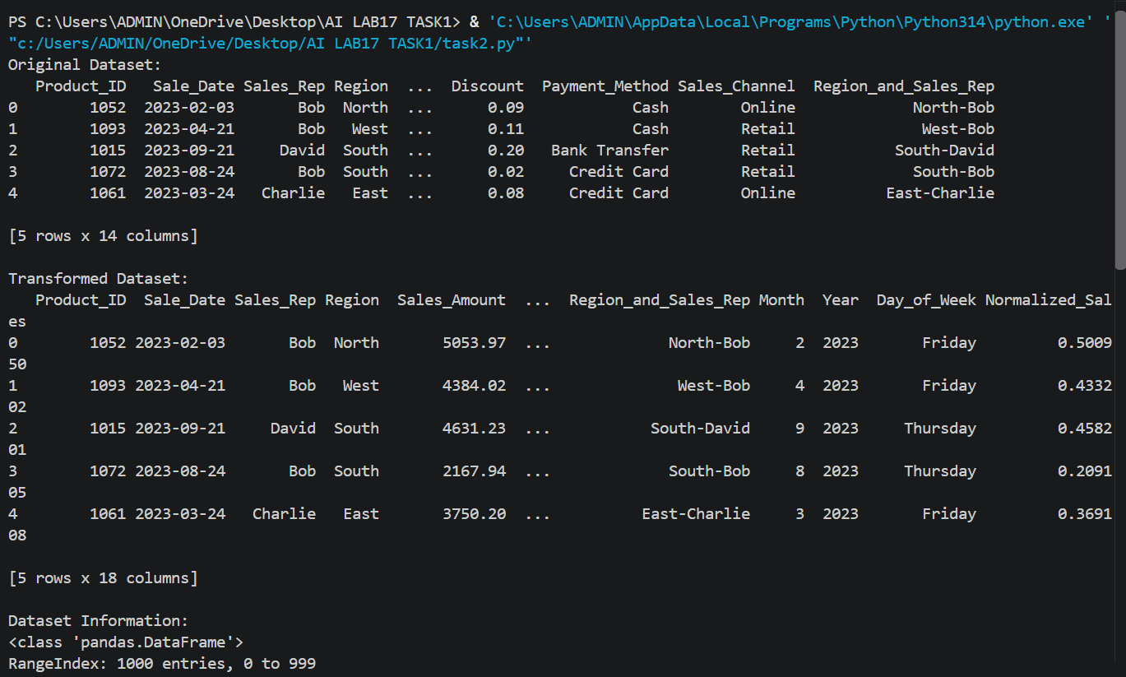
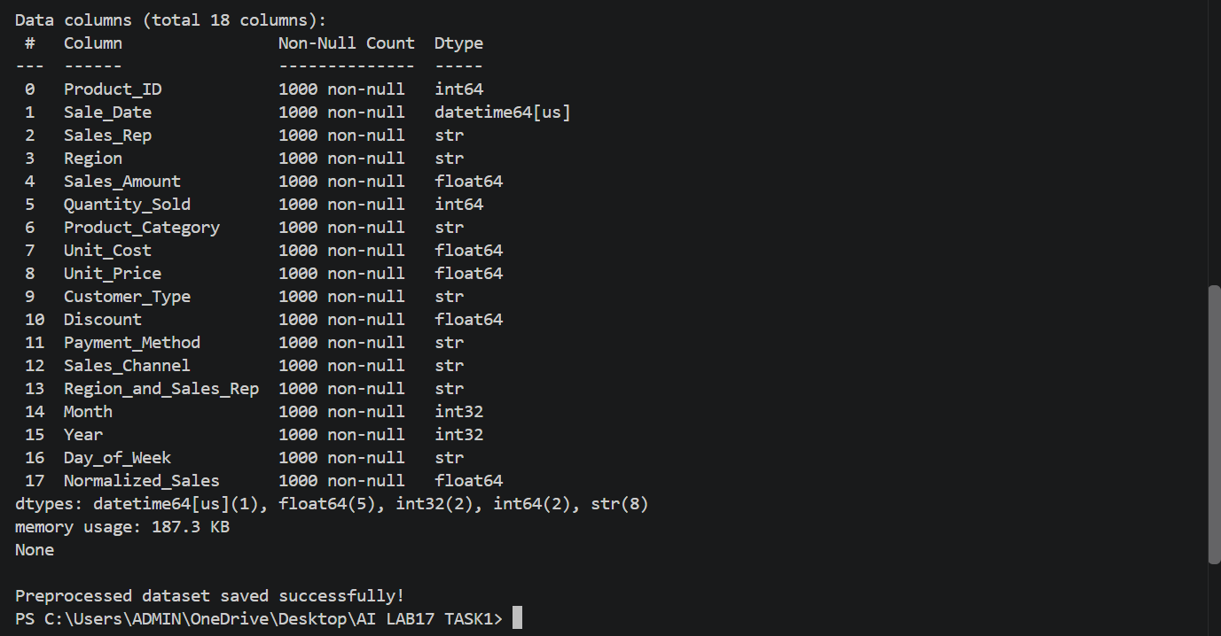
Task 3 – Healthcare Data Preparation
Aim:
To clean and preprocess a healthcare dataset using Python and Pandas by handling missing values, encoding categorical features, scaling numerical features, and splitting the dataset into training and testing sets for machine learning.
Prompt:
Generate a Python script to preprocess the healthcare risk factors dataset. Handle missing values in blood_pressure and cholesterol, encode categorical features, scale numerical features using Min-Max scaling, and split the dataset into 80% training and 20% testing sets. Display the preprocessed data.
Python Code:

import pandas as pd

# Load healthcare dataset
data = pd.read_csv("dirty_v3_path.csv")

print("Original Dataset:")
print(data.head())

# Standardize column names
data.columns = data.columns.str.strip()

# Split dataset into training and testing sets (80:20)
train_data = data.sample(frac=0.8, random_state=42)
test_data = data.drop(train_data.index)

# Identify numerical and categorical columns
numeric_cols = train_data.select_dtypes(
include="number"
).columns.tolist()

categorical_cols = train_data.select_dtypes(
include="object"
).columns.tolist()

# Handle missing numerical values
for col in numeric_cols:
median_value = train_data[col].median()

train_data[col] = train_data[col].fillna(median_value)
test_data[col] = test_data[col].fillna(median_value)

# Handle missing categorical values
for col in categorical_cols:
mode_value = train_data[col].mode()

fill_value = mode_value[0] if not mode_value.empty else "Unknown"

train_data[col] = train_data[col].fillna(fill_value)
test_data[col] = test_data[col].fillna(fill_value)

# Encode categorical features
train_data = pd.get_dummies(
train_data, columns=categorical_cols, dtype=int
)

test_data = pd.get_dummies(
test_data, columns=categorical_cols, dtype=int
)

# Make sure both datasets have the same columns
train_data, test_data = train_data.align(
test_data, join="left", axis=1, fill_value=0
)

# Scale numerical features using Min-Max scaling
for col in numeric_cols:
minimum = train_data[col].min()
maximum = train_data[col].max()

if maximum != minimum:
train_data[col] = (
(train_data[col] - minimum) / (maximum - minimum)
)

test_data[col] = (
(test_data[col] - minimum) / (maximum - minimum)
)
else:
train_data[col] = 0.0
test_data[col] = 0.0

# Display preprocessed datasets
print("\nTraining Dataset:")
print(train_data.head())

print("\nTesting Dataset:")
print(test_data.head())

# Display dataset shapes
print("\nTraining Data Shape:", train_data.shape)
print("Testing Data Shape:", test_data.shape)

# Save preprocessed datasets
train_data.to_csv("healthcare_train.csv", index=False)
test_data.to_csv("healthcare_test.csv", index=False)

print("\nHealthcare data preprocessing completed successfully!")
Output:
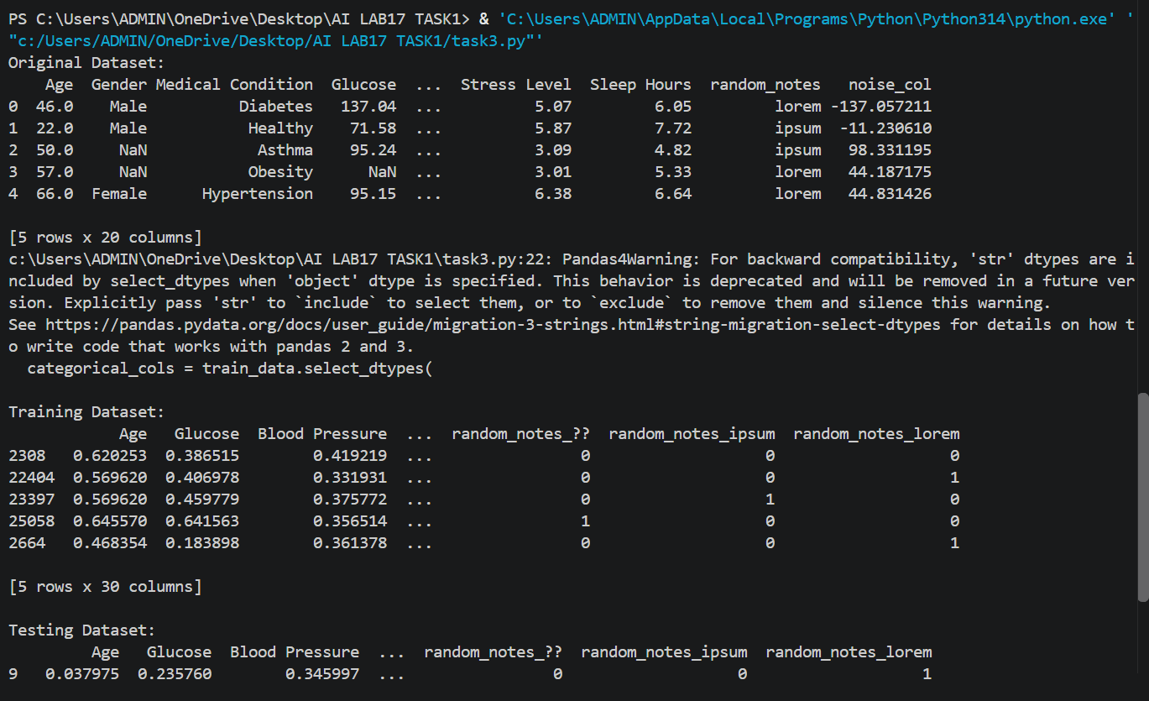
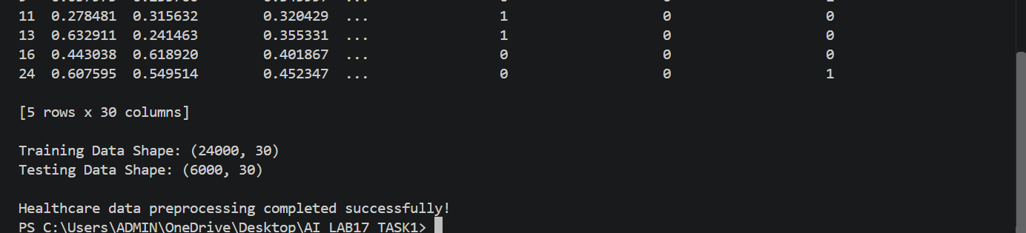
Task 4 – Employee Salary Data Preprocessing
Aim:
To clean and preprocess employee salary data by handling missing values, removing salary outliers, standardizing department names, and encoding categorical variables.
Prompt:
Generate a Python Pandas script to clean the employee salary dataset by handling missing values, detecting and removing salary outliers using the IQR method, converting department names to lowercase, and label encoding job location and department. Save the cleaned dataset as a CSV file.
Python Code:

import pandas as pd

# Load employee salary dataset
data = pd.read_csv("employee_salary.csv")

print("Original Dataset:")
print(data.head())

# Standardize column names
data.columns = data.columns.str.strip()

# Handle missing values
for col in data.select_dtypes(include="number").columns:
data[col] = data[col].fillna(data[col].median())

for col in data.select_dtypes(include="object").columns:
mode_value = data[col].mode()
fill_value = mode_value[0] if not mode_value.empty else "Unknown"
data[col] = data[col].fillna(fill_value)

# Identify salary column
salary_col = next(
(col for col in data.columns if col.lower() == "salary"),
None
)

# Detect and remove salary outliers using IQR
if salary_col:
Q1 = data[salary_col].quantile(0.25)
Q3 = data[salary_col].quantile(0.75)
IQR = Q3 - Q1

lower_limit = Q1 - 1.5 * IQR
upper_limit = Q3 + 1.5 * IQR

data = data[
(data[salary_col] >= lower_limit) &
(data[salary_col] <= upper_limit)
]

# Standardize department names
for col in data.columns:
if col.lower() == "department":
data[col] = data[col].astype(str).str.strip().str.lower()

# Encode job location and department
for col in data.columns:
if col.lower() in ["job location", "location", "department"]:
data[col] = pd.factorize(
data[col].astype(str)
)[0]

# Display cleaned dataset
print("\nCleaned Employee Dataset:")
print(data.head())

# Check missing values
print("\nMissing Values:")
print(data.isnull().sum())

# Save cleaned dataset
data.to_csv("cleaned_employee_salary.csv", index=False)

print("\nEmployee salary data cleaned successfully!")
Output:


